**Track and Field Application User Manual**

**Summary:**

This application allows athletes, coaches, head coaches to create an account, add events and meets, approve athletes for the season, update their info, communicate with the team in a chat room.

**Future enhancements/Limitations:**

Allow athletes to enter their choices for a meet, and allow head coach to assign athletes to a meet.

**Installation:** Follow the instructions on the README.md of the application to get the program up and running.

**Prerequisite to running the application:**

Visual Studio Code, Node.js, Angular cli, MySQL.

**How to use the application:**

1. Download the application, then type npm install to run the dependencies. Navigate to within src/app on the command line and then type r to run the backend node server. Import the MySQL dump file into MySQL.

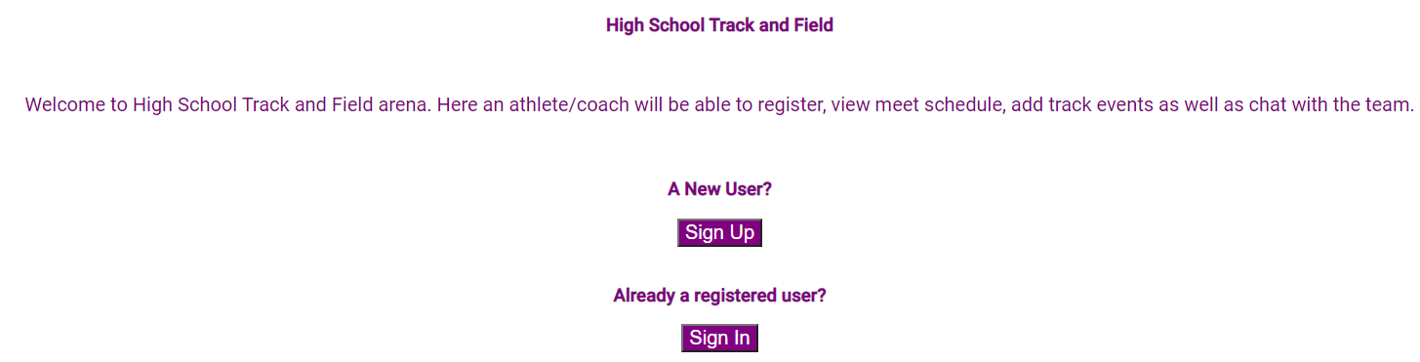

1. Sign up as athlete, coach, or head coach. 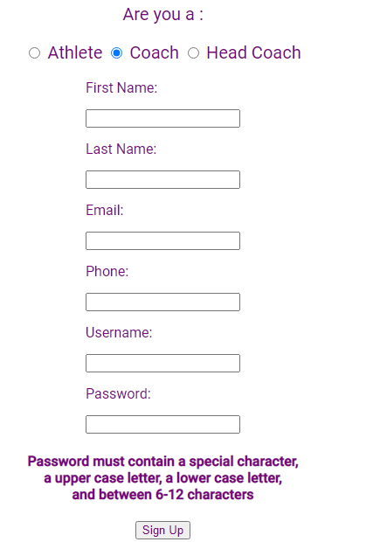 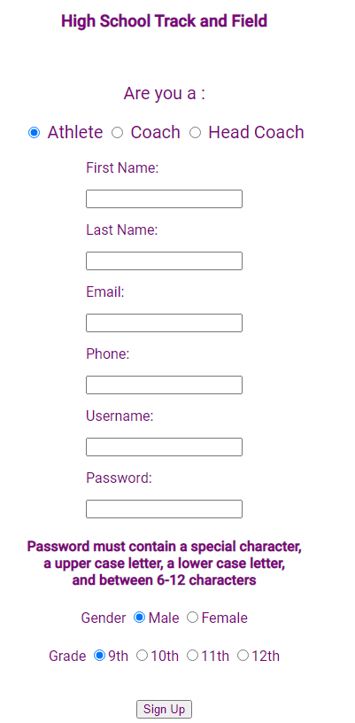

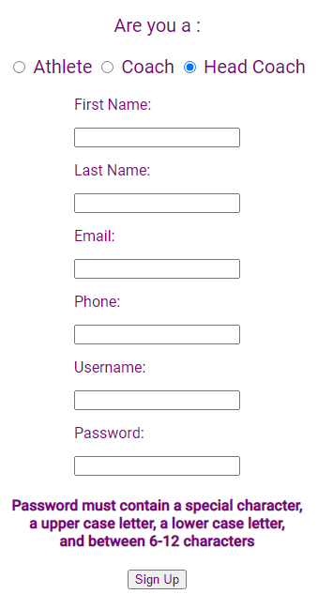

1. After signing up, log into your appropriate account.

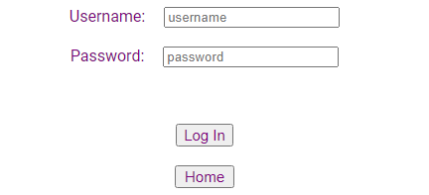

1. When an athlete logs in, they will be taken to their home page. 
2. Clicking on the myInfo page will display user information which then can be updated.

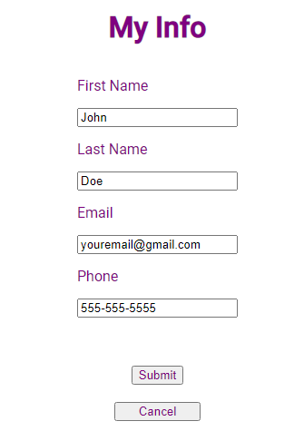

1. Meet schedule will give a list of meets that a coach or a head coach has entered. Athletes can only view these meets.

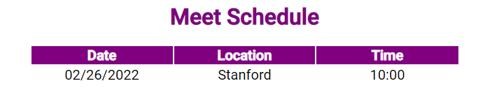

1. Chat will allow to communicate with the team. A user can update/delete only their chat. Other chats are for display only. New chat can be entered using plus icon.

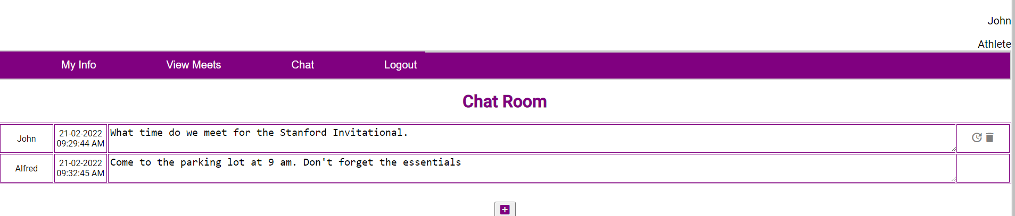

1. The menu for the head coach is

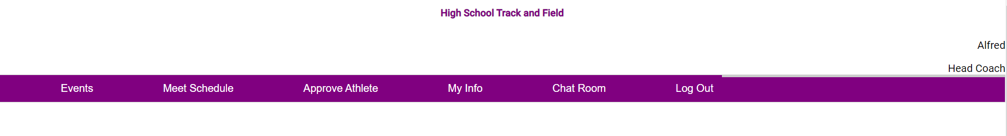

1. My Info works the same as an athlete
2. The head coach can manage the events the school participates in.

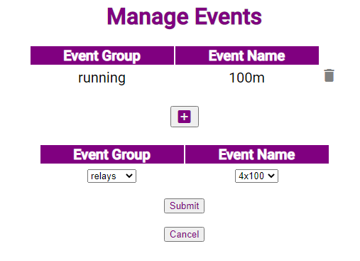

1. After submitting, the page updates to reflect the the newly added event.

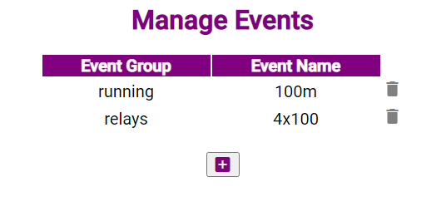

1. The head coach can also manage the meets the team is participating in.



1. Clicking on plus icon will allow head coach to add a meet. The meet can be updated or deleted using the icons next to meet details.

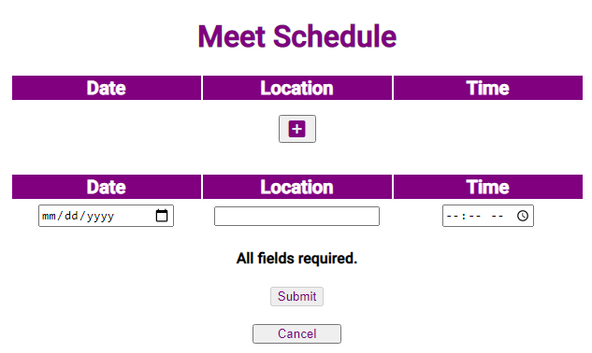

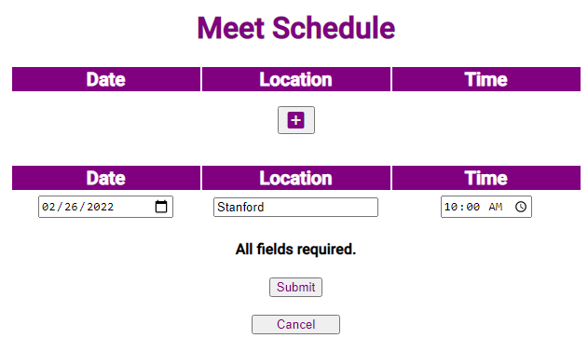

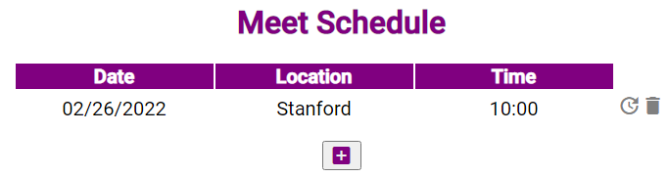

1. The head coach can approve an athlete.

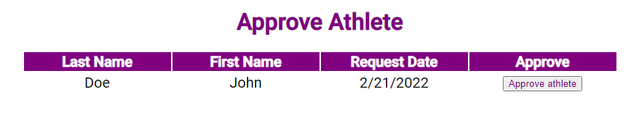

1. When an athlete is approved, an email is sent to that athlete and is removed from display.

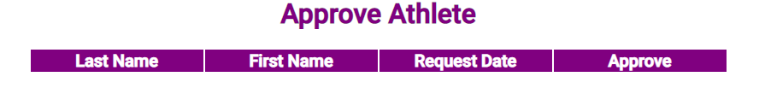

1. Chat works same as in an athlete.
2. The coach works the same like a head coach except they don’t have an authority to approve an athlete. The menu for the coach is

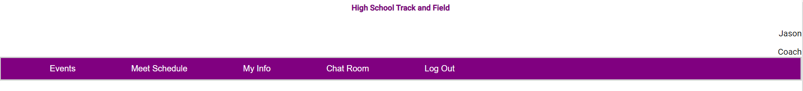

1. All screens display the username and the role (athlete, coach or head coach) on top right corner.